Syeda Reeha Quasar

14114802719

6C7

Aim

Write a program in NS3 to implement Bus Topology.

Experiment - 6

Computer Networks Lab

# **EXPERIMENT – 6**

## **Aim:**

Write a program in NS3 to implement Bus Topology.

## **Source Code:**

#include "ns3/core-module.h"

#include "ns3/network-module.h"

#include "ns3/csma-module.h"

#include "ns3/internet-module.h"

#include "ns3/point-to-point-module.h"

#include "ns3/applications-module.h"

#include "ns3/ipv4-global-routing-helper.h"

// Default Network Topology

//

// 10.1.1.0

// n0 -------------- n1 n2 n3 n4

// point-to-point | | | |

// ================

// LAN 10.1.2.0

using namespace ns3;

NS_LOG_COMPONENT_DEFINE ("SecondScriptExample");

int

main (int argc, char *argv[])

{

bool verbose = true;

uint32_t nCsma = 3;

CommandLine cmd (__FILE__);

cmd.AddValue ("nCsma", "Number of \"extra\" CSMA nodes/devices", nCsma);

cmd.AddValue ("verbose", "Tell echo applications to log if true", verbose);

cmd.Parse (argc,argv);

if (verbose)

{

LogComponentEnable ("UdpEchoClientApplication", LOG_LEVEL_INFO);

LogComponentEnable ("UdpEchoServerApplication", LOG_LEVEL_INFO);

}

nCsma = nCsma == 0 ? 1 : nCsma;

NodeContainer p2pNodes;

p2pNodes.Create (2);

NodeContainer csmaNodes;

csmaNodes.Add (p2pNodes.Get (1));

csmaNodes.Create (nCsma);

PointToPointHelper pointToPoint;

pointToPoint.SetDeviceAttribute ("DataRate", StringValue ("5Mbps"));

pointToPoint.SetChannelAttribute ("Delay", StringValue ("2ms"));

NetDeviceContainer p2pDevices;

p2pDevices = pointToPoint.Install (p2pNodes);

CsmaHelper csma;

csma.SetChannelAttribute ("DataRate", StringValue ("100Mbps"));

csma.SetChannelAttribute ("Delay", TimeValue (NanoSeconds (6560)));

NetDeviceContainer csmaDevices;

csmaDevices = csma.Install (csmaNodes);

InternetStackHelper stack;

stack.Install (p2pNodes.Get (0));

stack.Install (csmaNodes);

Ipv4AddressHelper address;

address.SetBase ("10.1.1.0", "255.255.255.0");

Ipv4InterfaceContainer p2pInterfaces;

p2pInterfaces = address.Assign (p2pDevices);

address.SetBase ("10.1.2.0", "255.255.255.0");

Ipv4InterfaceContainer csmaInterfaces;

csmaInterfaces = address.Assign (csmaDevices);

UdpEchoServerHelper echoServer (9);

ApplicationContainer serverApps = echoServer.Install (csmaNodes.Get (nCsma));

serverApps.Start (Seconds (1.0));

serverApps.Stop (Seconds (10.0));

UdpEchoClientHelper echoClient (csmaInterfaces.GetAddress (nCsma), 9);

echoClient.SetAttribute ("MaxPackets", UintegerValue (1));

echoClient.SetAttribute ("Interval", TimeValue (Seconds (1.0)));

echoClient.SetAttribute ("PacketSize", UintegerValue (1024));

ApplicationContainer clientApps = echoClient.Install (p2pNodes.Get (0));

clientApps.Start (Seconds (2.0));

clientApps.Stop (Seconds (10.0));

Ipv4GlobalRoutingHelper::PopulateRoutingTables ();

pointToPoint.EnablePcapAll ("second");

csma.EnablePcap ("second", csmaDevices.Get (1), true);

Simulator::Run ();

Simulator::Destroy ();

return 0;

}

## **Output:**

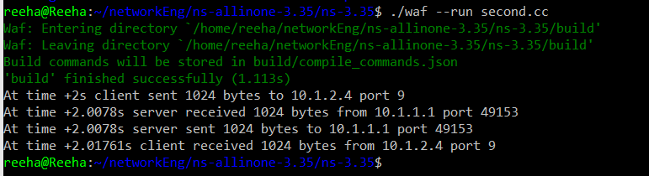

## **Viva Questions:**